## Lesson 24 – Activity Sheet

## Getting Started

* Designers can use **CAD** software to make accurate 2D and 3D drawings.
* Solid **modelling** with software such as AutoDesks 123Design is used to show how finished products will look.
* Different colours and textures can be added and the model can be rotated to show different views
* **Rapid prototyping** machines such as 3D printers can then be used to create prototypes of designs before mass production takes place

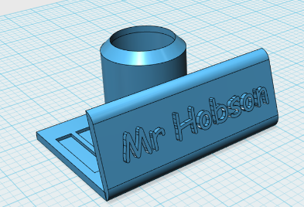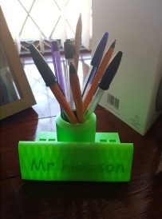

## To learn the basics of 123Design use the 123Design tutorial Video or Keyring Activity Sheet

## Success Criteria

* Represent a design in 3D using 123Design
* Design a plaque with your team name
* Design a box to keep your car in

## Pro-tip

* There are loads of online tutorials and pre-created designs on websites such as [thingiverse.com](http://www.thingiverse.com), so don’t re-invent the wheel.
* When using 123Design, ensure you keep an eye on the measurements.
* Each large square is 25mm and each small square is 5mm

## Test time

* Think Pair Share your ideas
* What happens when you select an edge and use the fillet or chamfer tool?
* What happens when you try to apply materials to different faces?
* Try **slicing** the object using free software such as Cura (<https://ultimaker.com/en/products/ultimaker-cura-software/list>) how long does it estimate the object will take to print?

## Stretch Tasks

* Design replacement wheels
* Design a body shell for you Bit:Bot
* Design a protective case for the sonic sensor

## Final Thoughts

* During today’s lesson we have looked at how 3D modelling software can be used to represent our plans/designs and how with the use of rapid prototyping machines we can get a complete example of our design before mass production begins.